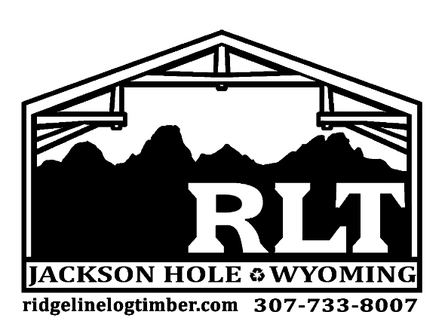

Product Specifications Sheet

Product Name:
Hand Hewn Timbers

Origin / History: Reclaimed from hand-built structures such as barns, mills, or other early agricultural/industrial structures. Most of our Hand Hewn Timbers come from structures that were often the first to be built in an area. Each timber was shaped with a broad axe as early craftsman didn’t always have access to a mill do to their location or year of origin. The history of our Hand Hewn timbers are truly unique in origin.

Surface Appearance Variation: Surface texture and patina will vary along the length of each timber and throughout each featured face. Based on their original positioning in a structure faces may contain more weathering and character than the next. Axe and adze marks are common characteristic of Hand Hewn Timbers but overall appearance remains unique. Hand Hewn timbers typically have 4 featured faces with a range of character variation. Timbers known as “sleepers” are also available with only 2 Hewn faces with rounded edges.

Knots, Nails and Pockets: Timbers may contain mortise pockets, cut tenons, peg holes, notches, old hardware, knots, checking, and cracks throughout. These unique attributes often make our Hand Hewn timbers the focal point of any room.

Dimensions: Hand Hewn timbers typically appear square and range in size. Inventory includes 6”x6” – 12”x12”+ with varying lengths, some up to 30’+. Rectangular sizes are very uncommon.

Colors: Color is indicative of their original use and can vary from shades of grey to shades of brown. Character staining and color variations are endless among timbers.

Applications: Interior applied timber assemblies can include trusses, ridge beams, furniture applications, and ceiling grids. Hand Hewn skins can also be used for accent walls and beam wraps. Exterior timber assemblies can include lintels, faux tails, knee braces, trusses, and porch systems.

Structural Integrity: Timbers can be used for structural components depending on grading requirements. Timber containing no mortise holes are typically graded for structural applications.

Availability: Product readily available depending on size needs.

