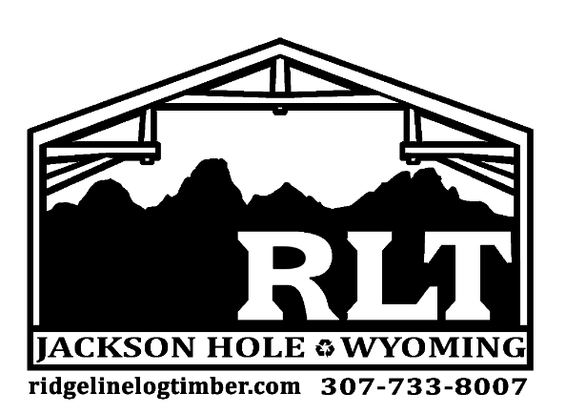

Product Specifications Sheet

Product Name:
Sawn Timbers

Origin / History: Reclaimed from hand-built structures such as barns and other early agricultural/industrial structures. Each timber was shaped by hand making them truly unique in origin.

Surface Appearance Variation: Axe and adze marks are defining characteristic of Hand Hewn Timber as they are some of the oldest timbers offered.

Knots, Nails and Pockets: Timbers may contain mortise pockets, cut tenons, peg holes, and old hardware. These unique attributes often make our Hand Hewn timbers the focal point of any room.

Dimensions: Hand Hewn timbers typically appear square and range in size. Inventory includes 6x6 – 12x12.

Colors: Color is indicative of their original use and can vary from shades of grey to shades of brown.

Applications: Interior applied timber assemblies can include trusses, ridge beams, furniture applications, and ceiling grids. Hand Hewn skins can also be used for accent walls and beam wraps. Exterior timber assemblies can include lintels, faux tails, knee braces, trusses, and porch systems.

Structural Integrity: Timbers can be used for structural components depending on grading requirements. Timber containing no mortise holes are typically graded for structural applications.

Availability: Product readily available depending on size needs.

At rlt the quality of our work is uncompromising as well as the materials we select for Ridgeline’s projects and inventory. Our long lasting relationships with our suppliers allow us to select only the finest materials to both use and supply. We supply various antique and reclaimed materials.

all materials have been generally demetaled and kept dry
passive solar kiln staging available for large orders

